Minimizing Risk in Ocean Shipping Contracts

Jackson Bronkema, Diego Victor Carlos Chavez, Asad Husain, Yuxuan Li, Kumar Rahul, Kshitij Virdi, and Yang Wang

Purdue University, Department of Management, 403 W. State Street, West Lafayette, IN 47907

jbronke@purdue.edu, carlos2@purdue.edu, [husain10@purdue.edu](mailto:husain10@purdue.edu), li4196@purdue.edu krahul@purdue.edu, kvirdi@purdue.edu, yangwang@purdue.edu

**Abstract**

Working with an undisclosed industry leader in the high-end home-furnishing industry, we modeled and forecasted ocean shipping volume by individual shipping lane for the furniture that our sponsor has imported into the United States on a month basis. This model and forecast will be used in the future by decision makers to stipulate the shipping volume that they need their partner carriers to import from Asia into the United States by lane. This forecast will mitigate the amount of risk our client is exposed to when negotiating shipping contracts with the ocean carriers that transport their products. Producing a robust model that can accurately predict future shipping volume is vital to our client because, prior to our work, they had no point of reference as to the amount of lane-wise shipping volume to expect each month. We used ARIMA and ETS models on the past seven years of lane-wise monthly shipping volume data to build a forecast for the next twelve months. We were able to effectively model the company's largest lanes by aggregate volume, which accounted for 65% of the total shipping volume our sponsor has imported in the past seven fiscal years. We chose the ARIMA and ETS models in R because of their high performance and ease of replicability over data of different shipping lanes.

**Keywords:**Shipping contracts, ocean carriers, lane, ETS, ARIMA, R.

Introduction

The international ocean freight market is estimated to have a value of $500 billion, comprised of over 170 carriers globally. However, approximately 20 carriers make up 90% of the annual revenue created by this industry. Out of the remaining revenue, 90% is accounted for by three major alliances within these carriers. As a result of this structure, the negotiating positions of these carriers are strengthened (Alperin et al., 2020).

The concept of intermodal transportation lies at the heart of ocean freight systems. All goods that are transported by ocean and waterway fall under the ocean freight umbrella. Ocean freight is cost-efficient, allows for greater overall capacity, and permits carriers to carry larger volumes in a single load, compared to any other form of transport. The process of intermodal transportation can be explained in six steps.

In the first place, a local trucking company picks up the goods in a shipping container at the shipper’s warehouse. The shipping containers are of two common types, TEU (Twenty-Foot Equivalent Unit) and FEU (Forty-foot Equivalent Unit). FEUs are constructed of two TEUs placed end to end. The container is sealed after being loaded so that goods it holds will not be tampered with. There are two main ways that cargo is loaded in a shipping container. In the case of the Full Container Load (FCL), the goods of only one shipper are loaded in the container. On the other hand, in the case of the Less than Container Load (LCL), smaller shipments of goods from more than one shipper are loaded in the container.

Second, the container is transported to a local distribution center. From there, it is routed to the port of loading via truck (if the port of loading is nearby) or via rail (if the port of loading is far away). Once the container is at the port of loading, the container is prepared to ship in the third step of this process and loaded onto the container ship by highly specialized equipment. From there, the container will be shipped to the destination port. In the fourth step, during the transit process from the port of loading to the destination port, the ship can take a direct route to the destination or, in many cases, that carrier will make several stops to drop off cargo at other destination locations enroute to the container’s destination. In the fifth step of the process, the container is given customs clearance at the destination port; it is transported via rail or truck to a distribution center near the customer’s location. Finally, a local logistics company delivers the container to the customer’s warehouse.

There are many different parties involved in the process of intermodal transportation. These include: the shipper, who is the owner of the goods demanded, the carrier, who is responsible for the shipping line that will transport the goods for the shipper, the consignee, who receives the shipment at the destination port, and finally, the freight forwarder, which is the company that facilitates the movement of the container throughout the process.

**The Shipper – Carrier Conundrum**

The ocean freight industry operates on fixed lane contracts. When the demand overwhelms the supply, the carriers reject the shipper's load forcing the shippers to the spot market. The spot market refers to the auction mechanism where shippers issue loads and carriers offer bids to fulfill the loads on a real-time basis (Sinha & Thykandi, 2019). The spot market is volatile to price fluctuations which can often lead shippers to pay up to three times more than contract prices.

From the perspective of the shipper, it is possible to experience a high number of load rejections by carriers, resulting in higher costs and reduced service performance according to the metrics defined by the sponsor company. Through this project, the goal is to reduce the number of shipments to the spot market. To evaluate the impact of the model, we developed an index that links monthly production units to the volume of shipping containers required by the shipper. Such a model would help shippers forecast the containers that would be required for their delivery. An insight into the expected number of containers would help shippers commit to the carriers in the form of a binding contract that would benefit both parties in the long run and would help strengthen the shipper-carrier relationship.

The shipper’s ocean carrier contract conundrum has been an important area of research since intermodal transportation has become a major form a transportation. The ocean freight community has continued to grow larger and stronger, in part because of the penalties that are being imposed on the shippers for under delivering on their commitments in recent years. In reverse, the shippers cannot impose any penalty for rejection of service by the ocean freight carriers and resort to the spot market to fulfill their deliveries. We observed this to be a common problem amongst all the shippers in the community. The statistics and scientific community have thoroughly investigated the problem using data-driven methods such as the ARIMA, Holt-Winter’s, SARIMA, ARIMAX, Random Forest and ETS models.

**Literature Review**

Ubaid et al. (2021) studied “the shortcomings of both short-term and long-term shipment demand forecasting for the Australian container shipping industry” (p. 1). They used the total inbound container (Filled), the total inbound container (Empty), and the starting day of the week as parameters for Long-Term and Short-Term Import demand forecasting. Import data and three years of historical demand were used. This research imported data from five international Australian ports for the Asia–Oceania trade lane. The study utilized three-time series forecasting models: the SARIMA model, the Holt–Winters’ seasonal method, and the Prophet model. The performance of each model was measured by using the following metrics: The Root Mean Squared Error (RMSE) and the Mean Average Percentage Error (MAPE). In the end, the study concluded that Facebook’s Prophet outperformed the other models in both short-term and long-term demand forecasting (Ubaid et al., 2021). This study is one of the few carried out so far for the Australian shipping industry.

Caplice et al. (2020) described the common problems in the trucking industry which are similar to the ones in the Ocean Carrier Industry and why shippers and carriers break contracts. When a shipper and a trucking company contract to transport goods at a given time and rate, there is no guarantee they will meet the agreement’s terms. The loads may never materialize, or the carrier may not have the capacity in the right place when it is scheduled to haul the cargo. (Caplice et al., 2020, MIT FreightLab section)

In this scenario, carriers reject the loads due to a change in shipping capabilities. Shippers withdraw from the agreement due to a change in the rules of the business, which causes cargo to become unavailable. As a result, this type of contract makes the shipping network ineffective and increases freight budgets. Speaking of solutions, MIT CTL’s FreightLab believes there should be an alternative contract. It proposes a possible solution to this problem: to classify each lane based on the lane stability and volume. Stable lanes will be served with a committed fleet, the lane with medium stability will be serviced by contract relationship, and unstable lanes will go to the spot market. The central idea of this solution is not novel, and many companies have tried this approach. This idea also fits into our project. We can classify distinct lanes by their volume into “high”, “medium,” and “low” and build a model for each category.

Song D. (2021) mentioned that the container shipping supply chain (CSSC) from a logistics viewpoint encompasses all-important logistical components such as freight logistics, container logistics, vessel logistics, port/terminal logistics, and inland transport logistics. The two most significant difficulties that CSSC faces are digitization and decarbonization. CSSC digitalization necessitates the use of digital technologies in various business processes across five logistics segments and a shift in supply chain behaviors and relationships. Maritime decarbonization would likely take a variety of paths, using various fuel/energy systems for ships and ports. We delve deeper to understand the impact it has on the pricing contract. The ocean carriers save on fuel by driving at lower speeds. Still, it impacts the business delivery schedule by a matter of weeks which has a significant financial impact on the shipper’s business.

Gökkuş et al. (2017) aimed to make a prediction model of the container traffic in the principal Turkish seaports. They used socioeconomic and demographic predictors such as gross domestic product (GDP), population, inflation rate, fuel price, total exports, and imports. The research employed the following models: The Artificial Neural Network with Artificial Bee Colony and Levenberg-Marquardt Algorithms (ANN-ABC and ANN-LM), the Multiple Nonlinear Regression with Genetic Algorithm (MNR-GA), and the Least Square Support Vector Machine (LSSVM) model. According to the study, the performance of each model was compared considering the MAPE, RMSE and R². The best performing models were LSSVM for Izmir and Istanbul seaports and ANN-ABC and ANN-LM models for the Mersin seaport. The present research states that:

The forecast results of this study were based on the 2023 objectives proposed by the Turkish Government, and it was assumed that these goals would be achieved. In the worst-case scenario, the model could overestimate the container traffic in the seaports. (Gökkuş et al., 2017, p. 13)

Dejan (2021), in his paper ‘Throughput forecasting of different types of cargo in the Adriatic seaport Koper’ addresses a new forecasting approach, which combines the Dynamic Factor Analysis (DFA) and the resulting Dynamic Factor Model (DFM) with the ARIMAX Box-Jenkins (BJ) modeling framework. The study's objective was to obtain information related to the highest possible accurate forecasts of trends of future cargo throughputs’ movements. The conducted framework gives promising prediction results, particularly for containers and total cargo.

A similar forecasting study from Zhao and Yaozong (2018) used R software to analyze the time series of the throughput of China’s major container ports dynamically. It mentions that the forecast of container port throughput was complex and uncertain in the research because it involves random up and downs influenced by various factors, such as economy and politics. We also face these uncertainties when building our shipping volume forecasting model. Scholars in this domain have proposed multiple modeling methods such as the curve fitting method, regression analysis method, gray prediction method, nonlinear trend analysis method, and the neural network method to deal with these random ups and downs. We can consider using these modeling methods when building the model concerning our business problem.

The article ‘Short term Forecast of Container Throughput: New Variables Application for the Port of Douala’ (Awah, 2021) aims to provide a practical method for forecasting the optimal container throughput a port can physically manage. It bases its methodology on the random forest (RF) and multilayer perceptron (MLP) models. Amongst the very few studies in the container throughput modeling literature on multivariate time series, socioeconomic, and growth projection factors, i.e., with factors such as GDP, interest rate, import/export, total output value, fixed asset investment, and population size, had been employed to model the optimal economic throughput of a port. The article results imply that the Random Forest model is effective with multivariate variables in forecasting the optimal engineering container throughput of Douala port. This study offers important knowledge that helps a port in optimizing bottlenecks. Therefore, it is vital to achieving accuracy and interpretability in throughput forecasting.

The paper ‘Container freight rate forecasting with improved accuracy by integrating soft facts from practitioners’ (Schramm, 2021) throws light on a novel approach to forecast freight rates in container shipping by integrating sentiments, confidence, or perception about the present and future market development through surveys among practitioners. They chose ARIMA, VAR, and ARIMAX models for forecasting while integrating exogenous factors like sentiments to forecast CCFI and SCFI. It concluded that those exogenous factors improved the overall performance compared to univariate modeling.

A study called “Time series forecasting using Holt-Winters exponential smoothing” (Lima, 2019) explains how the Holt-Winters model works with trendy and seasonal data. Its forecast will depend on the following three components of a seasonal time series: its level, its trend and its seasonal coefficient. It uses the moving average process to take the level, trend, and seasonal coefficients to aggregate the working model. The performance criteria used were the Mean Squared Error (MSE), the Root Mean Square Error (RMSE), the Mean Absolute Percentage Error (MAPE), the Mean Absolute Scaled Error (MASE), and Theil’s U-statistics. This model is particularly good for short-term forecasts.

A similar study that focuses on the ARIMA model (Fattah J., 2018) mentions that it is good in determining future demand. This model only needs past data to generalize the forecast and is most commonly used for short-term forecasts. On the other hand, the model is not useful for seasonal time series. Also, in another study that uses the ARIMA model, Intan Permatasaria et al. (2018) indicate that the model can be described as the union of two autoregressive (AR) model that is blended with the Moving Average (MA) model. (p. 2)

Finally, a study that uses different models to forecast COVID-19 cases explains that the ETS model is a modeling that captures different components (Error, Trend, Season) and makes short-term forecasts, which is appropriate in the case of strong dynamics. This model focuses on trend, seasonal components of different traits. ([Nicodème](https://www.sciencedirect.com/science/article/pii/S1110016821005470" \l "!) Atchadé & Morel Sokadjob, 2021, p. 3023).

**Table 1:** Literature Review Summary

|  |  |  |  |
| --- | --- | --- | --- |
| **Author** | **Target Variable Used** | **Model Type** | **Data used** |
| Ubaid, A. et al | Long-Term and Short-Term Import demand | SARIMA, Holt–Winters’ seasonal method and Prophet. | Total Inbound Container (Filled), Total Inbound Container (Empty) and Starting Day of the Week |
| Dragan, D. et al | Throughputs of seaports. | Dynamic Factor Analysis (DFA) and the resulting Dynamic Factor Model (DFM) with the ARIMAX Box-Jenkins (BJ) modeling framework, Holt-Winters and the SARIMA model. | GDP per capita (%), Purchasing power parity (PPP), Import (billions $) and Export (billions $). |
| Gökkuş, U. et al | Future container traffic. | Artificial Neural Network with Artificial Bee Colony and Levenberg-Marquardt Algorithms (ANN-ABC and ANN-LM), Multiple Nonlinear Regression with Genetic Algorithm (MNR-GA). | -Gross domestic product (GDP), Population, Inflation rate, Fuel price, Total exports and Total imports. |
| Schramm, H.-J., & Munim, Z. H. | Freight rates (CCFI and SCFI). | An autoregressive integrated moving average (ARIMA), ARIMAX and Vector Autoregressive (VAR). | Indices of sentiment, perception and confidence. |
| Awah, P. C. et al. | Optimal container throughput. | Random forest (RF), multilayer perceptron (MLP) and RF-MLP models. | Ship turnaround time (days), average vessel draft (meters), berth/crane productivity (container moves per hour), container dwell time (days), storage capacity (million tons), custom declaration time (days) and monthly container throughput (million tons). |
| Jin, Z., & Ding, Y. Z. | Container Throughput in China. | Autoregressive Moving Average Model (SARIMA). | Monthly data of the container throughput of the major ports in the country. |

**Methodology**

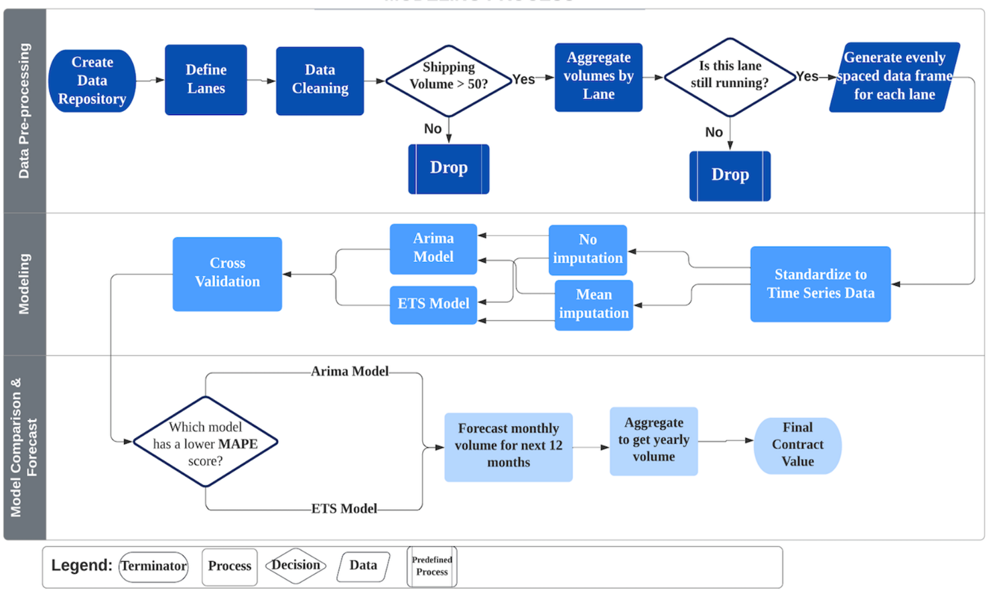

Our study aims to build a predictive model that forecasts the ocean shipping volume needed by lane for our sponsor. There is considerable research in predicting shipping demand in the ocean freight industry. Most other studies use data gathered before the year 2020. However, in our study, we use pre-Covid and post-Covid data, which features drastic changes in demand in the ocean shipping industry. Most of the research focuses on the ARIMA and Holt Winter’s models to make a forecast of future shipping demand. However, in our methodology, we only focused on the ARIMA and ETS model. When building the solution for our sponsor, we started by focusing on the data that they provided to us and understanding the business problem that they wanted us to solve. From there, we cleaned the data and conducted exploratory data analysis to better understand the trends of the variables in the dataset. Next, we performed lane-wise aggregation and imputation to prep the data for model training. We created functions to repeatedly deal with missing values in the individual lanes and then chose the best model to forecast it. The shipping data is sourced as a 6-month dump from their database. In merging all those datasets together, we get the combined shipping history, which we then use to define lane-wise time series. Our second function then creates another time series which is mean imputed, if needed. After modeling both these time series, we select the best ARIMA or ETS model, or the one with the lowest MAPE score. The end deliverable of our code is the following years’ aggregated volumes along with the following years’ monthly shipping volumes by lane. The client will use the following years’ aggregated (yearly) volume by lane to form the contract with the carrier. We concluded the project by comparing the performance of each model on the validation set. With our models in place, we were then able to deploy them and deliver the business insight and impact to our sponsor.

**Statistical Time Series Vs. Machine Learning**

Traditional statistical methods like ARIMA, SARIMA, and Holt-Winters have been used previously for predicting transport volumes. These methods, however, cannot explain changes in data caused by external processes, such as port closures caused by epidemics, financial crises, and major changes in people's lifestyles. Consequently, deep learning has become more and more popular among transportation volume analyses, as it can make predictions based on the laws inherent in the data and analyze the characteristics. For our analysis, we decided to move forward with traditional time series models to predict the future shipping volume at a given time for two reasons. First, we do not have access to exogenous factors that may affect the volume of shipments. Secondly, there is not a great amount data, and traditional time series models are fairly straightforward to implement on smaller datasets.

**Data Imputation Methods**

Time series are generally assumed to be generated at equally spaced time intervals. Our purpose is to forecast the total shipping volume of the sponsor companies’ largest lanes in the coming year. We first filtered out the transportation volume data for each lane, and then aggregate the shipping volume from daily intervals into monthly intervals. However, not every route has transportation every month, and roughly 90% of the routes that we modeled have a certain degree of missing months. The missing data percentage for the lanes that we modeled was anywhere from 5% to 59%.

The loss of values can cause problems due to the fact that subsequent data processing and analysis are often dependent on a complete dataset. Therefore, we need to replace missing values with reasonable values before building the models. Because different missing values are caused by different reasons, we performed the following imputation processes according to their causes and missing frequencies in the dataset:

* 1. Replace NAs with mean.
  2. Replace NAs with median.
  3. Replace NAs using linear interpolation method that assumes a linear relationship between the missing and non-missing values.

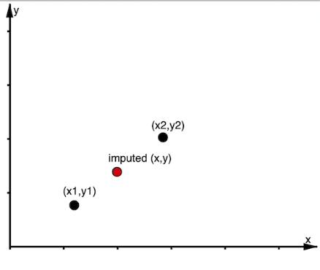

* 1. Replace NAs using Kalman filter with Arima model.

**Model Evaluation Method**

The Root Mean Square Error (RMSE), the Mean Absolute Error (MAE), the Mean Absolute Percentage Error (MAPE) and the Symmetric Mean Absolute Percentage Error (sMAPE) are metrics that can be used in evaluating the accuracy of a model and can be used correspondently. Our sponsor made it clear that it was vital to them that we provide them with the accuracy of each of our forecasts to a given percentage. To do this, we used MAPE to measure the accuracy of our model forecasts. MAPE is an accuracy measure based on the relative errors of each prediction in our forecast. For each lane, we chose the champion model by choosing the candidate model that had the lowest overall MAPE on the validation set, which was six months of the most recent shipping data for that lane. Using this statistic, can make a prediction – up to a certain percentage – how accurate the forecast for the monthly shipping volume will be. Below is the calculation of MAPE where *At* is the actual value and *Ft* is the predicted value.

$MAPE=\frac{1}{n}\sum_{ t=1}^{ n}{\left|\frac{At-Ft}{At}\right|}$

**Data**

In collaboration with a national retailer, we were provided granular raw data in an excel file format which consisted of various attributes displaying information on imperative business aspects of the retailer in the ocean freight business for the past few years. Some of the key attributes of the raw data have been described below.

**Table 2**Data dictionary

|  |  |
| --- | --- |
| Attribute | Description |
| B/L | Bill of Lading: Official shipping document carrying shipment details |
| Container Number | Unique identifier for the shipment container which is a standardized metal box |
| Shipment Number | Unique identifier for the shipment route |
| Origin Number | Unique identifier for the origin city, state, and country |
| Carrier Name | Unique identifier of carrier that ships container from origin port to discharge port |
| POL | Port of Loading: Port at which goods are loaded for the shipment |
| POD | Port of Discharge: Port at which goods are unloaded |
| Arrival Date | Date that shipment arrived the destination port |
| Departure Date | Date that shipment departed from origin port |
| Container Type | Unique identifier for container types as per ISO standards |
| Volume | Volume of shipment in CBM (cubic meter) |

# Model

Our client was most concerned with the accuracy of the model over the interpretability of the model. Our goal was to model and forecast the shipping volume in cubic meters for each of these large lanes using total shipping volume over the past four years. Having the task of predicting the shipping volume across many different lanes, it became evident very quickly that we would need to use different types of models on the different shipping lanes. We could not use a one-size-fits-all strategy, because there did not seem to be a strong correlation in the amount of shipping volume between any of these lanes. Most of the shipping lanes had very different trends and seasonality from each other. Our goal was to automate the modeling process as much as we possibly could, so we created a function using R that would allow us to test multiple different types of models on each of the top lanes. Each of these models would be trained on different months of data (22-96 months) and then tested on a validation set of the most recent 6 months of data.

For the modeling process on each lane, we used ten candidate models from three different families of time series models (ARIMA and ETS model). Among these were an auto-ARIMA model which is an optimized model generated by the *forecast* package in R, and many different Holt-Winters smoothing models with different parameters for their error, trend, and seasonality. These specific parameters allowed us to build additive and multiplicative smoothing models. We also attempted to create ARIMA(p,d,q)(P,D,Q) [12] models by manually tunning the model’s 6 parameters using ACF and PACF plots on the models' residuals, but this process was very time consuming and our sponsor can't reproduce this model because they don’t have the knowledge on ARIMA model tunning. Having run the data for each shipping lane through the function, we were able to generate an RMSE (statistic of choice), MAE, MAPE, sMAPE for each of our ten models on each shipping lane. This allowed us to easily compare the results of each of the lanes and choose the one with the smallest test error (MAPE). Taking the best model for each shipping lane, we could then visualize the model on past data along with a future forecast for demand. Below is an example of our model in green trained to the test data in black, with our future forecast for the shipping volume in blue. Here is an example on the eight largest shipping lane that we were modeling which is the cargo that was shipped form Ningbo, China to North East, U.S.

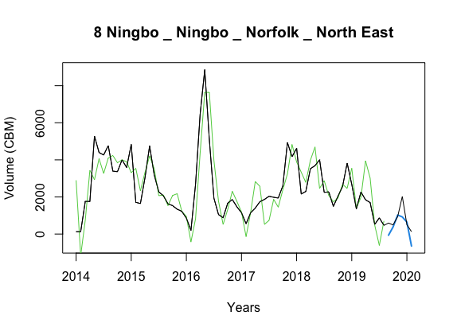

# Results

Here are the forecasting results of many of the shipping lanes. The title represents the shipping lane starting from origin to the destination city. The actual values are black, and our model's fitted values are green. The blue line represents a twelve-month forecast of the shipping volume. We used cross-validation instead of the train-test type of evaluation to make more efficient use of the data present. The top 6 lanes where our models could most accurately forecast the volumes are the following:

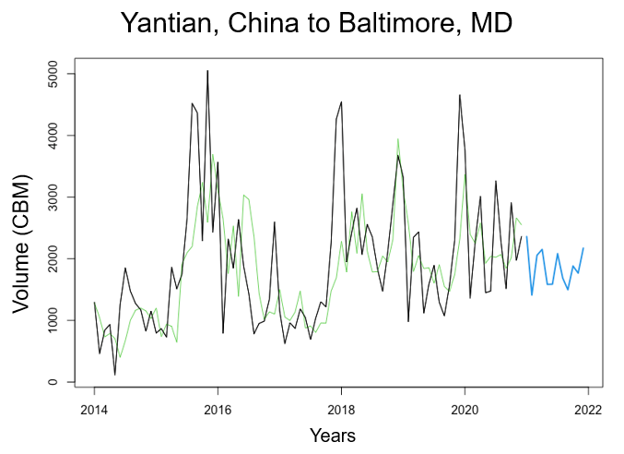

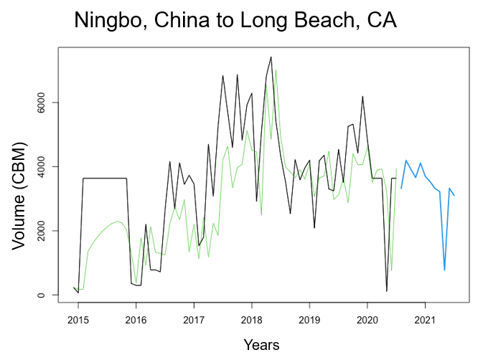

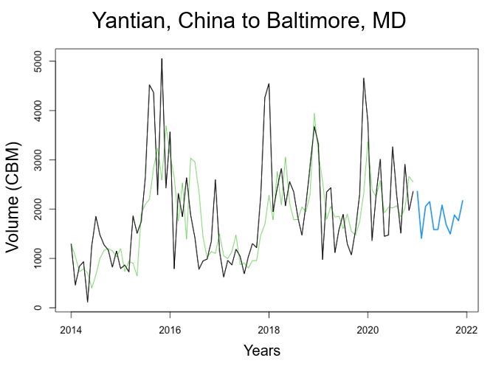

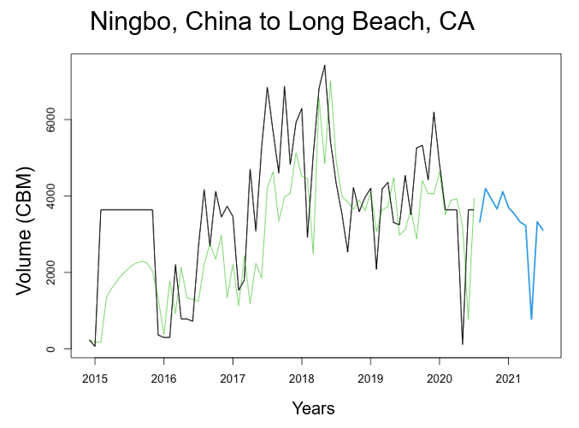

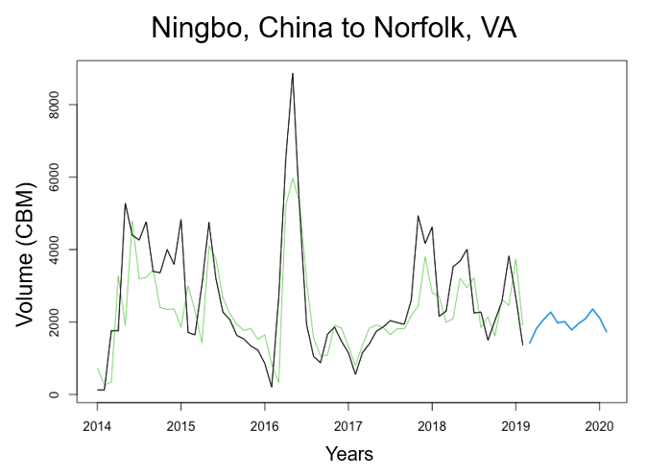

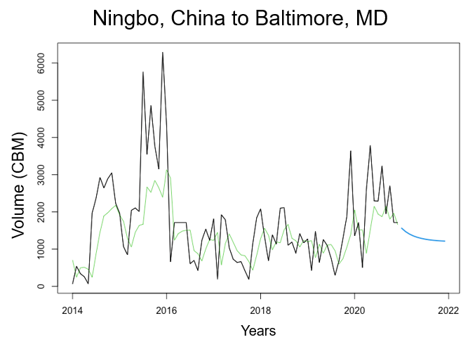

**Expected Impact**

The client requirement included delivering a relative evaluation metric enabling them to compare the accuracy of various shipping lane forecasts. To do this, we used MAPE, or mean absolute percentage error. MAPE is an accuracy measure based on the relative errors of each prediction in our projections. We chose the champion model for each lane by choosing the candidate model with the lowest overall MAPE post cross-validation. Using this statistic, we can predict up to a certain percentage of how accurate the forecast for the monthly shipping volume will be.

These predictions will help our client save money on shipping costs. Over twelve months, our forecasts are 17.7% more accurate on average. Assuming that our sponsor is forced to go to the spot market for all the volume they inaccurately estimate, we can say that the sponsor will save approximately $4.46 million using our time series forecasts over the past twelve months.

Another benefit of more accurate lane-wise forecasting is that it enables our client to build trust with its partner carriers. Building this trust increases the probability that the carriers will fulfill the sponsors' shipping demands, thus fewer contract defaults for our client and better shipping rates.

**Conclusions**

We attempted to train over ten candidate models on each of the largest shipping lanes for our client through the modeling process. Each lane differed in volume and the number of missing values. This was a problem that we needed to combat. One of the main drivers of our success in this project was that we tried a wide variety of imputation methods on missing data for each of the lanes. We then trained each of these candidate models on the differing data. We then selected the candidate model with the lowest MAPE. Please refer to the table below for the results.

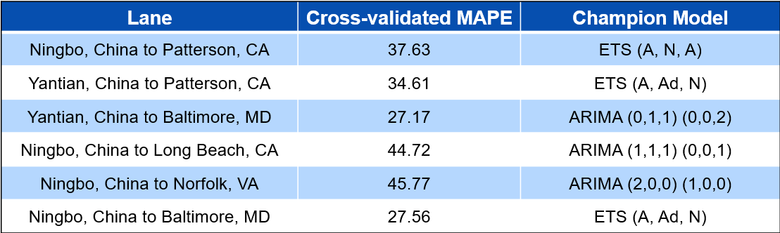

We come away from this project feeling confident that we could provide our client with powerful time series forecasting models that outperform the previous system that they were using to stipulate lane-wise volume to the carriers they work with. We project that our client will save millions of dollars in the next contract season by implementing our models. We have created an application for the sponsor – using R Shiny – that will allow them to run the models each month as their data or business scenario changes.

# References

Ubaid, A., Hussain, F., & Saqib, M. (2021). Container Shipment Demand Forecasting in the Australian Shipping Industry: A Case Study of Asia–Oceania Trade Lane. *Journal of Marine Science and Engineering*, *9*(9), 1-20. <https://doi.org/10.3390/jmse9090968>

Caplice, C., Correll, D., & Cottrill, K. (2020, December 17). In search of alternatives to Truckload's fragile freight contracts. Medium. Retrieved January 28, 2022, from <https://medium.com/mitsupplychain/insearch-of-alternatives-to-truckloads-fragile-freight-contracts-b856675e3f30>

ČIžiūnienė, K., Meidutė-Kavaliauskienė, L., Topolšek, D., & Torok, A. (2021). A Literature Review, Container Shipping Supply Chain: Planning Problems and Research Opportunities. *Logistics*, *5*(2), 1–26. <https://doi.org/10.3390/logistics5020041>

Dragan, D., Keshavarzsaleh, A., Intihar, M., Popović, V. & Kramberger, T. (2021). Throughput forecasting of different types of cargo in the adriatic seaport Koper, *Maritime Policy & Management*, *48*(1), 19-45. <https://doi.org/10.1080/03088839.2020.1748242>

Gökkuş, Ü., Yıldırım, M. S., & Aydin, M. M. (2017). Estimation of Container Traffic at Seaports by Using Several Soft Computing Methods: A Case of Turkish Seaports. *Discrete Dynamics in Nature and Society*, *2017*, 1–15. <https://doi.org/10.1155/2017/2984853>

Schramm, H.-J., & Munim, Z. H. (2021). Container freight rate forecasting with improved accuracy by integrating soft facts from practitioners. *Research in Transportation Business & Management*, *41*, 1–11. <https://doi.org/10.1016/j.rtbm.2021.100662>

Lima, S., Gonçalves, A. M., & Costa, M. (2019). Time series forecasting using Holt-Winters exponential smoothing: An application to economic data. *AIP Conference Proceedings, 2186*, 1 – 4. <https://doi.org/10.1063/1.5137999>

Fattah, J., Ezzine, L., Aman, Z., El Moussami, H., & Lachhab, A. (2018). Forecasting of demand using ARIMA model. *International Journal of Engineering Business Management*, *10*, 1–9. <https://doi.org/10.1177/1847979018808673>

Awah, P. C., Nam, H., & Kim, S. (2021). Short Term Forecast of Container Throughput: New Variables Application for the Port of Douala. *Journal of Marine Science and Engineering*, *9*(7), 1-20. <https://doi.org/10.3390/jmse9070720>

Jin, Z., & Ding, Y. Z. (2018). Prediction of Container Throughput in China. *Chinese Studies, 7*, 12-20. <https://doi.org/10.4236/chnstd.2018.71002>

Sinha, A., & Thykandi, R. (2019, June). *Alternate Pricing Model for Transportation Contracts*. Center for Transportation & Logistics, MIT. <https://hdl.handle.net/1721.1/121309>

Alperin, D., Storch, T., & Messerly, B. (2020). *Ocean Freight Market Update - 2020 Trends & Best Practices*. Insight Sourcing. Retrieved March 15, 2022, from <https://www.insightsourcing.com/ocean-freight-market-update-2020/>

Nicodème Atchadé, M., & Morel Sokadjob, Y. (2022). Overview and cross-validation of COVID-19 forecasting univariate models. *Alexandria Engineering Journal*, *61*(4), 3021–3036. <https://doi.org/10.1016/j.aej.2021.08.028>.

Intan Permatasari, C., Sutopo, W., & Hisjam, M. (2018). Sales forecasting newspaper with ARIMA: A case study. *AIP Conference Proceedings, 1931*(1). <https://doi.org/10.1063/1.5024076>